
Healthy Halloween Snack Ideas

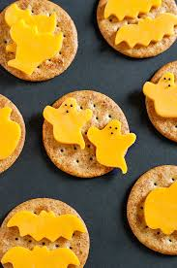
Cheese ghosts
These spooky savoury snacks are really simple to make with some cheese cut out in the shape of ghosts or bats and put on crackers.

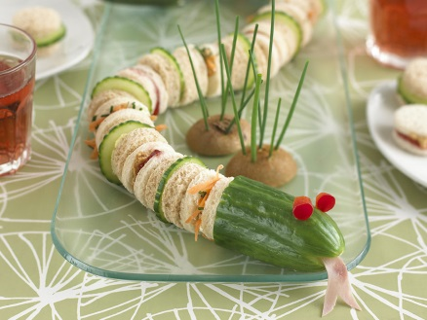
Snake sandwiches
Small, round sandwiches filled with cheese, cucumber or ham can be displayed in the shape of a slithery snake with a cucumber head.

Orange pumpkins
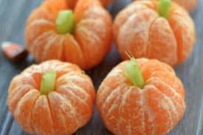
Small oranges such as satsumas or clementine’s can be peeled to look like pumpkins, with a little bit of celery for a stalk.

Banana ghosts
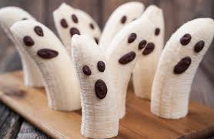
Bananas make great ghoulish ghosts. Raisins can be used to decorate their faces.

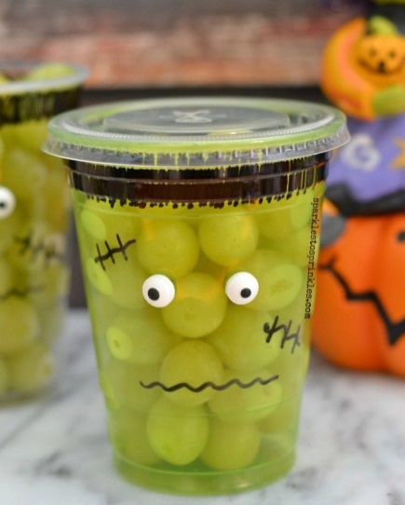
Monster fruit cups
Clear plastic cups can be decorated to make some freakish faces and then filled with fruit, such as grapes or a fruit salad. Children will have great fun decorating the cups.

Pumpkin fruit kebabs
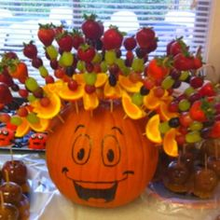
Pumpkins make great holders for fruit kebabs.

Melon faces
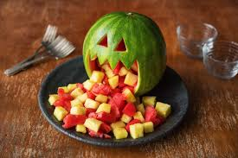
Water melons can be carved to make some fiendish faces to store some tasty melon chunks.
Cheese broomsticks
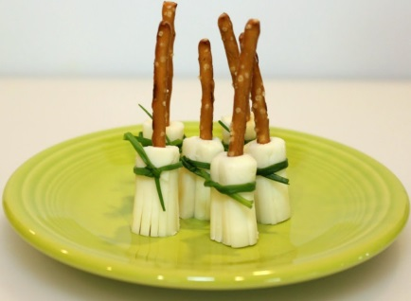
Wicked witches broomsticks can be made using pretzel or bread sticks, string cheese and a chive.

Have you got any other ideas? Share them with us on Twitter @HLHLDoncaster

